Deployment Package
Version Control with CVS

Notes:
This document is the intellectual propriety of its author’s organization. However, information contained in this document is free of use. The distribution of all or parts of this document is authorized for non commercial use as long as the following legal notice is mentioned:

© École de Technologie Supérieure

Commercial use of this document is strictly forbidden. This document is distributed in order to enhance exchange of technical and scientific information.
This material is furnished on an “as-is” basis. The author(s) make(s) no warranties of any kind, either expressed or implied, as to any matter including, but not limited to, warranty of fitness for purpose or merchantability, exclusivity, or results obtained from use of the material.
The processes described in this Deployment Package are not intended to preclude or discourage the use of additional processes that Very Small Entities may find useful.

Author | L. BEGNOCHE – École de Technologie Supérieure (ETS), Canada
Editors | C. Y. LAPORTE – École de Technologie Supérieure  ANA VAZQUEZ – 5th level, (México)
Creation date | 10 March 2008
Last update | 30 July 2026
Status | Draft
Version | 0.2

Versions

Date  (yyyy-mm-dd) | Version | Auteur | Modification
2008 03 12 | 0.1 | L.BEGNOCHE | Document creation
2009 07 27 | 0.2 | C LAPORTE | Overall Review and implementation of new template

Abbreviations/Acronyms

Abre./Acro. | Definition
DP | Deployment Package - a set of artefacts developed to facilitate the implementation of a set of practices, of the selected framework, in a Very Small Entity.
VSE | Very Small Entity – an enterprise, organization, department or project having up to 25 people.
VSEs | Very Small Entities
SCM | Software Configuration Management.
PM | Project Management Process as defined in ISO/IEC ISP 29110-5-1.
SI | Software Implementation Process as defined in ISO/IEC ISP 29110-5-1.

Table of Contents
1. Technical Description 4
Purpose of this document 4
Why Version Control is Important ? 4
2. Definitions 5
Generic Terms 5
Specific Terms 5
3. Relationships with ISO/IEC 29110 7
4. Description of Processes, Activities, Tasks, Steps, Roles and Products 8
Tasks 8
Define the Delivery Instructions 8
Document the Version Control Strategy 9
Establish the Project Repository 10
Perform a Project Repository Backup 10
Perform a Project Repository Recovery 11
Incorporate Software Configuration Item 11
Deliver a Software Configuration 12
Roles & Artefacts 13
5. Description of CVS Subtasks 15
Task/CVS subtasks traceability matrix 15
CVS subtasks description 15
Install CVS 15
Backup a CVS repository 16
Recover a CVS repository 17
Create a module 17
Download a copy of an existent software product version 19
Create a new software product version 22
Delete an existent software product version 24
Modify an existent software product version: Add a software item 26
Modify an existent software product version: Delete a software item 33
Modify an existent software product version: Modify a software item 37
6. Reference to ISO and ISO/IEC Standards and Models 49
ISO/IEC29110 Part 5 (Basic Profile) Reference Matrix 49
ISO/IEC 12207 Reference Matrix 50
CMMI Reference Matrix 51
7. References 53
8. Evaluation Form 54

1. Technical Description

Purpose of this document
The purpose of this document, titled “Deployment Package – Version Control with CVS”, is to provide VSEs with tailorable and easily usable guidelines and materials in order to implement a good version control process.
This Deployment Package (DP) supports the Basic Profile as defined in ISO/IEC 29110 Part 5-1: Management and Engineering Guide. A DP is a set of artefacts developed to facilitate the implementation of a set of practices in a Very Small Entity (VSE). A DP is not a process reference model (i.e. it is not prescriptive). The elements of a typical DP are: description of processes, activities, tasks, roles and products, template, checklist, example, reference and reference to standards and models, and tools.

In Part 5, the VSE is required to develop a Version Control Strategy. The strategy is composed of the following elements:
- Product repository tools or mechanism identified
- Location and access mechanisms for the repository specified
- Version identification and control defined
- Backup and recovery mechanisms defined
- Storage, handling and delivery (including archival and retrieval) mechanisms specified

This document has been produced by ETS (Ecole de Technologie Supérieure - www.etsmtl.ca) beyond their official participation to ISO JTC1/SC7/WG24.

Why Version Control is Important ?
While developing software products, change happens. Because it happens, it is necessary to control it effectively. Software Configuration Management (SCM), which encapsulates version control, is a set of activities designed to control the evolution of a software product.

A lack of control along with the complex co-ordination of software product’s evolution over many years by many developers often lead to many problems related to the integrity of the software product.

In other term, the organization may verify the software product is developed in accordance with all established processes and may validate that the software product is developed as required; at the end, if the changes to the software product were not correctly controlled it is highly probable that the delivered software product will not be the right one.

This document defines an easy to follow process with a free tool in order to minimize the cost of implementing version control.

2. Definitions
In this section, the reader will find two sets of definitions. The first set defines the terms used in all Deployment Packages, i.e. generic terms. The second set of terms used in this Deployment package, i.e. specific terms.

Generic Terms

Process: set of interrelated or interacting activities which transform inputs into outputs [ISO/IEC 12207].

Activity: a set of cohesive tasks of a process [ISO/IEC 12207].

Task: required, recommended, or permissible action, intended to contribute to the achievement of one or more outcomes of a process [ISO/IEC 12207].

Sub-Task: When a task is complex, it is divided into sub-tasks.

Step: In a deployment package, a task is decomposed in a sequence of steps.

Role: a defined function to be performed by a project team member, such as testing, filing, inspecting, coding. [ISO/IEC 24765]

Product: piece of information or deliverable that can be produced (not mandatory) by one or several tasks. (e. g. design document, source code).

Artefact: information, which is not listed in ISO/IEC 29110 Part 5, but can help a VSE during the execution of a project.

Specific Terms
Software product:
Set of computer programs, procedures, and possibly associated documentation and data.
[ISO 12207:2008]

Configuration item:
Entity within a configuration that satisfies an end use function and that can be uniquely identified at a given reference point.
[ISO 12207:2008]

Non-deliverable item:
Hardware or software product that is not required to be delivered under the contract but may be employed in the development of a software product.
[ISO 12207:2008]

Baseline:
Specification or product that has been formally reviewed and agreed upon, that thereafter serves as the basis for further development, and that can be changed only through formal change control procedures.
[ISO 12207:2008]

Version:
Identified instance of an item.
NOTE Modification to a version of a software product, resulting in a new version, requires configuration management action.
[ISO 12207:2008]

3. Relationships with ISO/IEC 29110
This deployment package covers the activities related to Version Control of the ISO Technical Report ISO/IEC 29110 Part 5-1 for Very Small Entities (VSEs) – Basic Profile [ISO/IEC29110].

In this section, the reader will find a list of Project Management (PM) and Software Implementation (SI) process, activities, tasks and roles from Part 5 that are directly related to this topic. This topic is described in details in the next section.

- Process: <Number and Title>
- Activity: <Number and Title>
- Tasks and Roles:

Tasks | Roles
- <Number and Title> | Abbreviation

Note:
- Tasks are listed sequentially in section but this doesn’t imply any lifecycle behind.
- There are no rules regarding the precise format of an artefact.
- Each of the Steps described below must be adapted to the organisation and project context.

Tasks:
- Define the Delivery Instructions
- Document the Version Control Strategy
- Establish the Project Repository
- Perform a Project Repository Backup
- Perform a Project Repository Recovery
- Incorporate Software Configuration Item
- Deliver a Software Configuration

4. Description of Processes, Activities, Tasks, Steps, Roles and Products

Tasks

Define the Delivery Instructions
Objectives: | To define what products are delivered to the customer and how they are delivered.
Rationale: | It is important to define the delivery instructions to make sure the software configuration management process fulfils the customer needs in term of what is delivered and how it is delivered.
Roles: | Project Manager
Roles: | Customer
Artefacts: | Delivery Instructions (documented in the project plan)
Steps: | - Identify the software products to deliver
Steps: | - Define the naming and versioning convention for each software product
Steps: | - Define the content and structure of each software product
Steps: | - Define the media to deliver each software product
Step Description: | Step 1. Identify the software products to deliver:  During this step, the project manager and customer identify the software products that must be delivered to the customer.  Software product:  Set of computer programs, procedures, and possibly associated documentation and data.  [ISO 12207:2008]  Step 2. Define the naming and versioning convention for each software:  During this step, the project manager and customer define how the software products shall be named. The intent could be to allow useful information to be deduced from the names based on regularities. Or the intent could be to reflect a trademark.  Moreover, the project manager and the customer define a software versioning scheme. The intent is to assign either unique version names or unique version numbers to distinct software configurations of a given software product.  Step 3. Define the content and structure of each software product:  During this step, the project manager and the customer define the content of each software product that will be delivered. The location of specific content and the structure of the content should be defined. Moreover, it is necessary to distinguish configuration items that are delivered from non-deliverable item.  Configuration item:  Entity within a configuration that satisfies an end use function and that can be uniquely identified at a given reference point.  [ISO 12207:2008]  Non-deliverable item:  Hardware or software product that is not required to be delivered under the contract but may be employed in the development of a software product.  [ISO 12207:2008]  Step 4. Define the media to deliver each software product:  During this step, the project manager and customer identify the media to use to deliver each software product. The intent is to define whether to use a secured or non-secured media and which type of digital media: web site, ftp site, e-mail, CD-ROM, etc.  The output of those steps is a set of delivery instructions documented in the project plan.

Document the Version Control Strategy
Objectives: | To document procedures, tools, mechanisms to store and handle versions of software products and other configuration items.
Rationale: | It is important to define the version control strategy for all stakeholders to be able to perform the software configuration management process used in the project.
Roles: | Project Manager
Roles: | Technical Leader
Artefacts: | Version Control Strategy (documented in the project plan)
Steps: | Not applicable
Description: | Since this document describes almost everything needed in a version control strategy, the simplest is to refer to this document for procedures and tools. However, the location of the project repository and the access rights are specific to the project and must be documented in the project plan.  The output of this task is a version control strategy documented in the project plan.

Establish the Project Repository
Objectives: | To prepare the project repository in accordance with the version control strategy documented in the project plan.
Rationale: | It is important to prepare the project repository for all stakeholders to have the necessary tools to perform the software configuration management process when necessary.
Roles: | Project Manager
Artefacts: | Version Control Strategy
Artefacts: | Project Repository
Steps: | See  4.2.1 Install CVS  4.2.4 Create a module
Description: | The project repository shall be prepared to support the software configuration management process. Procedures and tools described in this document in addition to location and access rights described in the version control strategy shall be followed and supported by the project repository.  The output of this task is a usable project repository.

Perform a Project Repository Backup
Objectives: | To backup the content and history stored in the project repository.
Rationale: | It is important to perform regular backup of the project repository to prevent any lost of data if hardware or software failure occurs.
Roles: | Project Manager
Artefacts: | Project repository
Artefacts: | Project repository backup
Steps: | See 4.2.2 Backup a CVS repository
Description: | A backup of the project repository shall be performed as described in this document. The backup shall be stored at a distinct location from the project repository location.  The output of this task is a project repository backup.

Perform a Project Repository Recovery
Objectives: | To restore the content and history in the project repository.
Rationale: | It is important to recover the project repository backup to correct any lost of data if hardware or software failure occurs.
Roles: | Project Manager
Artefacts: | Project repository
Artefacts: | Project repository backup
Steps: | See 4.2.3 Recover a CVS repository
Description: | If necessary, a recovery of the project repository shall be performed as described in this document.  The output of this task is a recovered project repository.

Incorporate Software Configuration Item
Objectives: | To baseline configuration items, to control changes to those configuration items and to make available those changes to all concerned stakeholders.
Rationale: | As a product evolves, it is important to create and use several baselines to control its development and testing. The quality of the configuration management process directly impact the quality of the final software products.
Roles: | Project Manager
Roles: | Technical Leader
Artefacts: | Project Repository
Artefacts: | Software Configuration
Artefacts: | Software Configuration Item
Steps: | See  4.2.5 Download a copy of an existent software product version  4.2.6 Create a new software product version  4.2.7 Delete an existent software product version  4.2.8 Modify an existent software product version: Add a software item  4.2.9 Modify an existent software product version: Delete a software item  4.2.10 Modify an existent software product version: Modify a software item
Step Description: | A software configuration represents the assignment of an identifier to a collection of configuration items. A baseline is a specialization of a software configuration that has been formally reviewed and agreed upon.  Baseline:  Specification or product that has been formally reviewed and agreed upon, that thereafter serves as the basis for further development, and that can be changed only through formal change control procedures.  [ISO 12207:2008]  Baselines and software configurations can be simply viewed as versions of a software product. Baselines are versions that have been formally reviewed and agreed upon. Software configurations are any other versions like prototypes, demo, internal versions, branches, etc.  Note that a version includes non-delivered items used for the development and testing of the software product.  Version:  Identified instance of an item.  NOTE Modification to a version of a software product, resulting in a new version, requires configuration management action.  [ISO 12207:2008]  Versions and configuration items included in versions can be created, modified and deleted.  The output of this task is a project repository containing software product versions and their history.

Deliver a Software Configuration
Objectives: | To deliver the software products to the customer in accordance with the delivery instructions.
Rationale: | It is important to deliver the software products since it is the major part of the contract with the customer.
Roles: | Technical Leader
Artefacts: | Delivery Instructions (documented in the project plan)
Artefacts: | Software Configuration
Steps: | See 4.2.5 Download a copy of an existent software product version
Description: | See the delivery instructions documented in the project plan for a description of this task. The delivery instructions should have been documented in task 3.1.1 Define the Delivery Instructions.

Roles & Artefacts

Role | Definition
Customer | Knowledge of the Customer processes and ability to explain the Customer requirements.  The Customer (representative) must have the authority to approve the requirements and their changes.
Project Manager | Leadership capability with experience making decisions, planning, personnel management, delegation and supervision, finances and software development.
Technical Leader | Knowledge and experience in the software development and maintenance.
Table 1 Definitions of Roles

Artefacts | Definition
Delivery Instructions
Version Control Strategy
Project Repository | A repository with the following characteristics:  - Repository for work products  - Storage and retrieval capabilities  - Ability to browse content  - Listing of contents with description of attributes  - Sharing and transfer of work products between affected groups  - Effective controls over access  - Maintain work products descriptions  - Recovery of archive versions of work products  - Ability to report work products status  - Changes to work products are tracked to Change Requests  The applicable status is: recovered.
Project Repository Backup | Repository used to backup the Project Repository and if necessary to recover information.
Software Configuration | A consistent set of software products including:  - Requirements Specification  - Software Design  - Traceability Record  - Components  - Software (unit, product, item)  - Test Cases and Test Procedures  - Defect Report  - Product Operation Guide  - Software User Documentation  - Maintenance Documentation  The applicable statuses are: delivered and accepted.
Table 2 Definitions of Artefacts

5. Description of CVS Subtasks

Task/CVS subtasks traceability matrix

Task | CVS subtask(s) performed during the task
Define the Delivery Instructions | No CVS tasks are performed.
Document the Version Control Strategy | No CVS tasks are performed.
Establish the Project Repository | Install CVS  Create a module
Perform a Project Repository Backup | Backup a CVS repository
Perform a Project Repository Recovery | Recover a CVS repository
Incorporate Software Configuration Item | Download a copy of an existent software product version  Create a new software product version  Delete an existent software product version  Modify an existent software product version: Add a software item  Modify an existent software product version: Delete a software item  Modify an existent software product version: Modify a software item
Deliver a Software Configuration | Download a copy of an existent software product version

CVS subtasks description

Install CVS

Purpose
The purpose of installing CVS is to establish a repository where many software products will be stored and controlled. During the installation, CVS accounts are created and access permission are defined.

Outcomes
As a result of successful installation of CVS:

a) CVS Server and clients are installed in the environment.

b) A new and empty repository is created on the CVS server.

c) CVS accounts are created and access permission are defined.

Step by step Description
Download the following software :
Software | Freely available at | Tested with version | On platform
CVSNT | www.cvsnt.org | 2.5.03.2382 | Windows
TortoiseCVS | www.tortoisecvs.org | 1.8.31 | Windows
Winmerge | www.winmerge.org | 2.6.8 | Windows

To install the CVS server, read the documentation that comes with CVSNT and follow carefully the directives to install CVSNT, to create accounts and to set access permission. It is recommended to use one CVS repository by project since it reduces the complexity of the accounts and user permission.

Note that it is possible to install CVS on a linux server even if the clients are on windows.

To setup the user machines, installs TortoiseCVS and Winmerge on each user machine. Those software are easier to install and setup than CVSNT. Documentation comes with both but normally the learning curve will be very fast for many users.

Note that there are many ways to use CVS in order to accomplish the CVS tasks described here. However, it is better to enforce user to perform the same process to avoid defects and subsequent corrective actions.

Backup a CVS repository

Purpose
The purpose of backuping a CVS repository is to copy the repository content and history.

Outcomes
As a result of successful backup of CVS repository:

a) CVS repository is copied on another location.

Step by step Description
Unfortunately, CVS does not offer a simple solution that garantee the integrity of the backup while users are using the CVS repository. Consequently, it is easier to schedule nightly backups.

For each backup, stop CVSNT, copy all the repository structure under another location, restart CVSNT.

The following batch script can be use for backups.
net stop cvsnt
xcopy "C:\cvsrepository" "C:\cvsbackup" /Q /S /C /H /R /O /Y /I
net start cvsnt
Where the correct paths must be used to make the copy.

Recover a CVS repository

Purpose
The purpose of recovering a CVS repository is to restore the repository content and history from a previous backup.

Outcomes
As a result of successful recovery of CVS repository:

a) CVS repository is recovered from a previous backup.

Step by step Description
CVS repository cannot be recovered while the CVS server is running.

For each recovery, stop CVSNT, delete all the repository structure, copy the repository structure from another location, restart CVSNT.

The following batch script can be use for recovery.
net stop cvsnt
rmdir "C:\cvsrepository" /Q /S
xcopy "C:\cvsbackup" "C:\cvsrepository" /Q /S /C /H /R /O /Y /I
net start cvsnt
Where the correct paths must be used to make the copy.

Create a module

Purpose
The purpose of creating a module is to establish a storage area where all the software items contained in a specific software product will be recorded and controlled. The software items will be available to every CVS user with the necessary access permissions.

Outcomes
As a result of successful creation of a module:

a) A new and empty module is created on the CVS server.

b) A new and empty directory is created locally.

Step by step Description
Open Windows Explorer and create a local directory that has the name of the new software product. Right-click on the new directory and select “CVS/Make New Module…”.

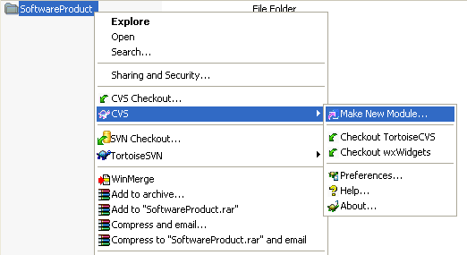

Verify the settings such as the server and repository names and click the “OK” button.

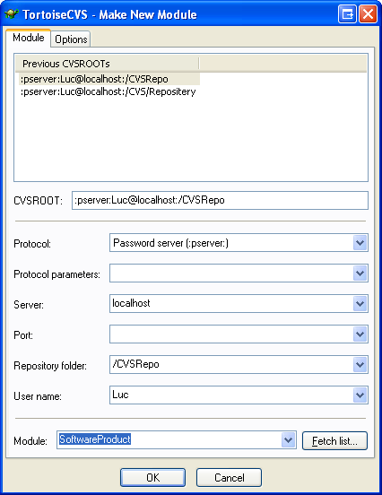

If successful, the following log will appear. Click the “OK” button.

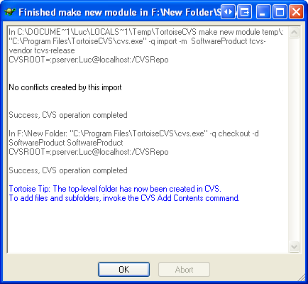

Verify that the empty module has been created locally in the chosen directory. The directory icon will have changed.

The empty module is now available to every CVS user with the necessary access permissions. It is now possible to add software items (subdirectories and files) in the software product.

Download a copy of an existent software product version

Purpose
The purpose of downloading a copy of an existent version is to implement or verify a given version of a given software product.

Outcomes
As a result of successful download of a copy of an existent software version:

a) A directory containing the version of the software product is created locally.

Step by step Description
Open Windows Explorer and go into the drive or directory where the software product should be downloaded. Right-click from inside the drive or directory and select “CVS Checkout…”.

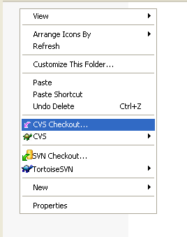

Verify the settings such as the server and repository names. Choose the software product (module) from the combo box. If the software product is no listed in the combo box, click the “Fetch list…” button beside to retrieve the list of modules available on the CVS server.

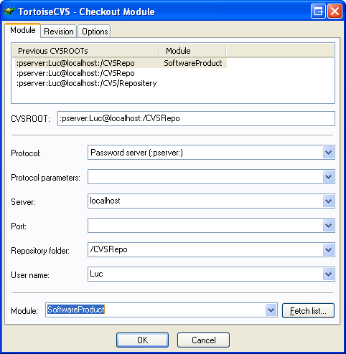

Go into the “Revision” tab, select “Choose branch or tag” and choose the version from the combo box. If the version is no listed in the combo box, click the “Update list…” button beside to retrieve the list of versions available for the given software product. Click the “OK” button.

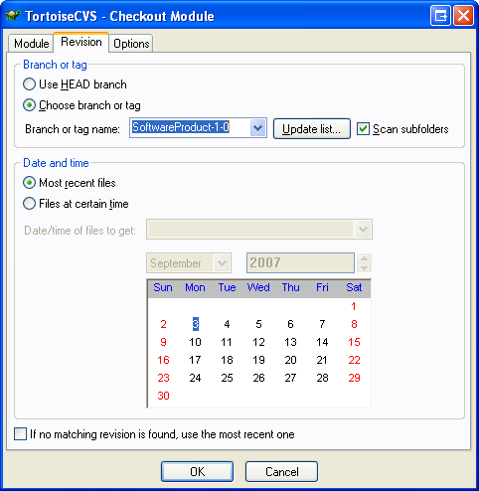

If successful, the following log will appear, listing all the software items included in the given version og the given software product. Click the “OK” button.

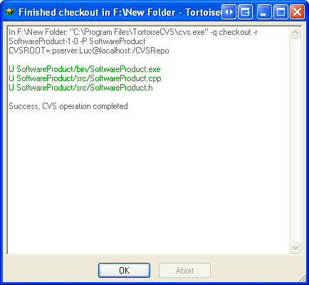

Verify that the software product has been downloaded locally in a new directory.

It is now possible to add, modify and delete software items (subdirectories and files) in the software product.

Create a new software product version

Purpose
The purpose of creating a new version is to develop a new version of a given software product, starting from an existent version. The version will be available to every CVS user with the necessary access permissions.

Outcomes
As a result of successfully creation of a new version:

a) A new version of the software product is created on the CVS server. The new version is identical to the previous existent version.

Step by step Description
Get a copy of the previous existent version by performing task Download a copy of an existent version.

Right-click on the new directory and select “CVS/Tag…”.

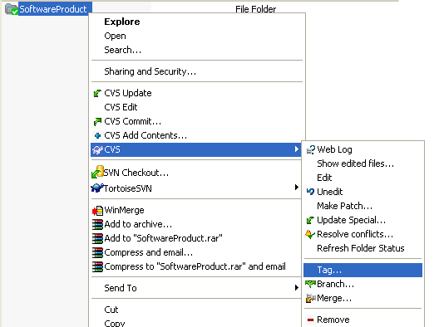

Select “Create new tag” and enter the new version in the combo box. Click the “OK” button.

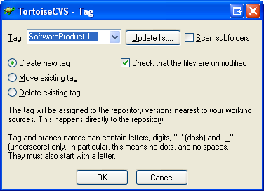

If successful, the following log will appear, listing all the software items included in the new version. Click the “OK” button.

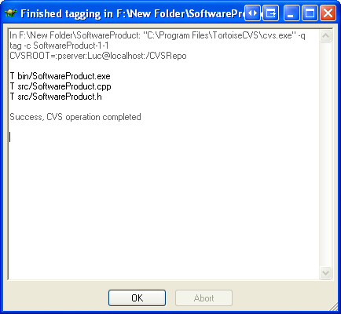

It is now possible to add, modify, and delete software items (subdirectories and files) in the software product.

Delete an existent software product version

Purpose
The purpose of deleting an existent version is generally to create again the same version from scratch.

Note that this task cannot be reverted; the deleted version cannot be restored automatically. However, the history of modifications on every software item is not altered.

Outcomes
As a result of successful deletion of an existent version:

a) The version of the software product is deleted on the CVS server.

Step by step Description
Download a copy of the existent version to delete by performing task Download a copy of an existent version.

Right-click on the new directory and select “CVS/Tag…”.

Select “Delete existing tag” and choose the version from the combo box. If the version is no listed in the combo box, click the “Update list…” button beside to retrieve the list of versions available for the given software product. Click the “OK” button.

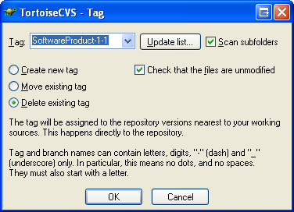

If successful, the following log will appear, listing all the software items included in the deleted version. Click the “OK” button.

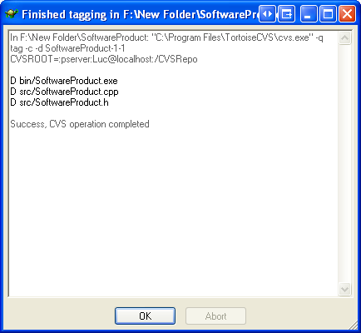

The local directory can be deleted manually.

Modify an existent software product version: Add a software item

Purpose
The purpose of modifying an existent version is to record and make available modifications to every CVS user with the necessary access permissions.

Outcomes
As a result of successful addition of a software item to an existent version:

a) The software item is added to the CVS server.

b) The version of the software product is modified on the CVS server. The software item is added to it.

Step by step Description
Unfortunately, it is impossible to add a software item on the CVS server using a copy of an existent version. First, it is necessary to download a copy of the “HEAD” version of all software items by performing task Download a copy of an existent software product version and selecting the “HEAD”. It is recommended to get a copy of the “HEAD” in a different directory.

Add the software item under the “HEAD” directory. Right-click from inside the directory and select “CVS Add Contents…”.

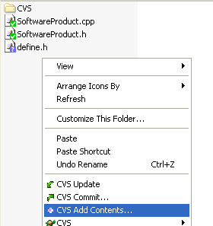

Select the software item to add and click the “OK” button.

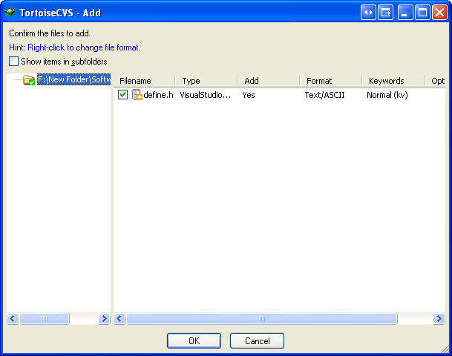

If successful, the following log will appear. Click the “OK” button. Note that nothing is added to the CVS server yet. The task can be reverted at this point by deleting the software item locally.

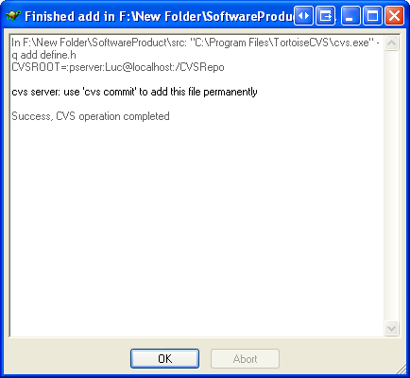

Right-click from inside the directory and select “CVS Commit…”.

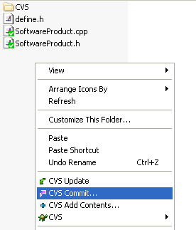

Write a comment that will enforce traceability with the version description. The reference and description of the change that requires the addition shall be recorded. More information may be recorded. Click the “OK” button.

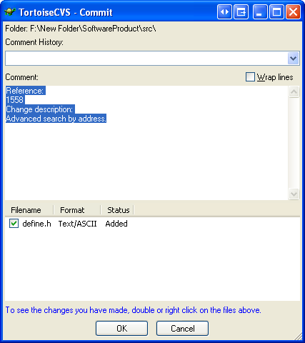

If successful, the following log will appear, listing the software item added to the CVS server. Click the “OK” button.

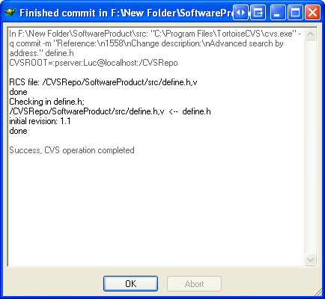

Right-click on the added software item and select “CVS/History…”.

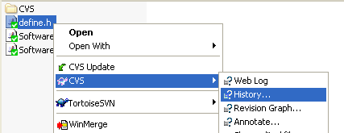

Right-click on the single software item revision displayed in the history and select “Tag…”.

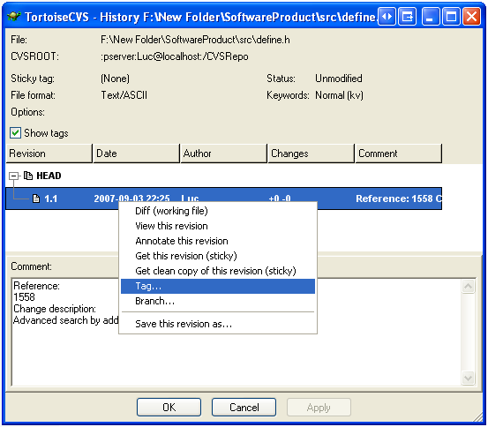

Select “Create new tag” and enter the version in the combo box. Click the “OK” button.

If successful, the following log will appear, listing the software item added to the version. Click the “OK” button.

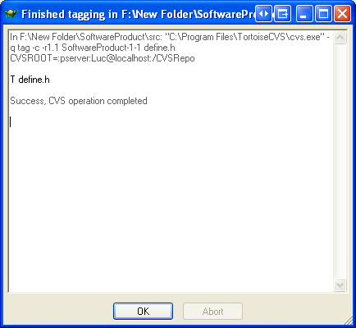

Verify that the software product version is linked to the correct software item revision and click “OK”.

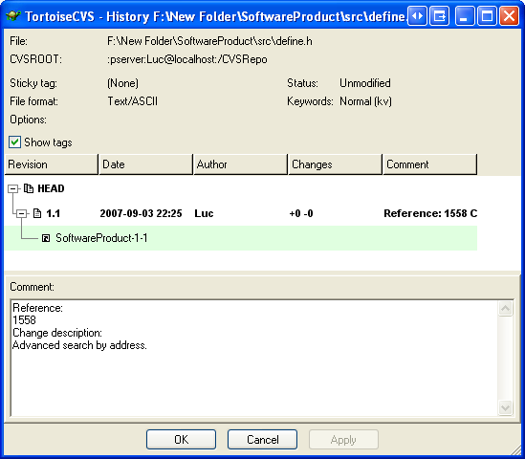

It is now possible to modify and delete the added software item.

Modify an existent software product version: Delete a software item

Purpose
The purpose of modifying an existent version is to record and make available modifications to every CVS user with the necessary access permissions.

Note that the history of modifications on the deleted software item is not lost. A new modification in the history specifies that it has been deleted.

Outcomes
As a result of successful deletion of a software item from an existent version:

a) The software item is deleted from the CVS server.

b) The version of the software product is modified on the CVS server. The software item is deleted from it.

Step by step Description
Unfortunately, it is impossible to delete a software item on the CVS server using a copy of an existent version. First, it is necessary to download a copy of the “HEAD” version of all software items by performing task Download a copy of an existent software product version and selecting the “HEAD”. It is recommended to get a copy of the “HEAD” in a different directory.

Under the “HEAD” directory, right-click on the software item to delete and select “CVS/Tag”.

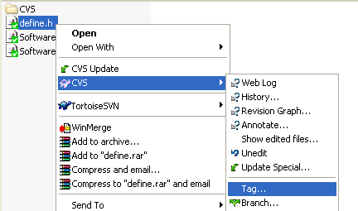

Select “Delete existing tag” and choose the version from the combo box. If the version is no listed in the combo box, click the “Update list…” button beside to retrieve the list of versions available for the software product. Click the “OK” button.

If successful, the following log will appear, listing the software item deleted from the version. Click the “OK” button.

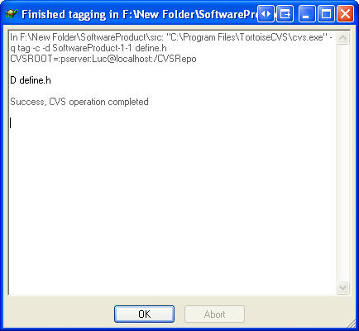

Right-click on the software item and select “CVS/Remove”.

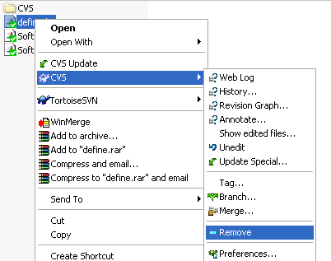

If successful, the following log will appear. Click the “OK” button.

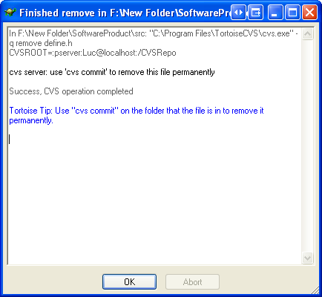

Right-click from inside the directory and select “CVS Commit…”.

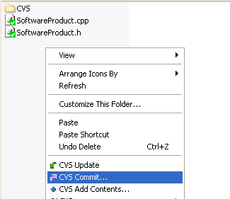

Write a comment that will enforce traceability with the version description. The reference and description of the change that requires the deletion shall be recorded. More information may be recorded. Click the “OK” button.

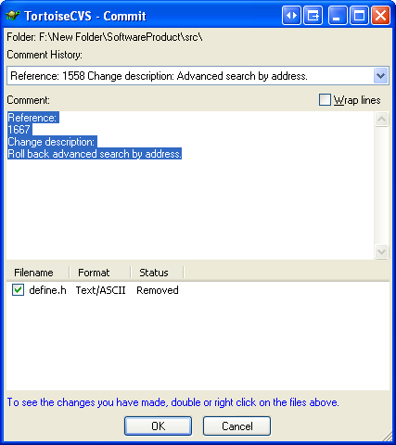

It is now impossible to modify the deleted software item. If the deleted software item must be modified in another version, it must be added again.

Modify an existent software product version: Modify a software item

Purpose
The purpose of modifying an existent version is to record and make available modifications to every CVS user with the necessary access permissions.

Note that a new modification in the history specifies that the software item has been modified.

Outcomes
As a result of successfully modifying a software item in an existent version:

a) The software item is modified on the CVS server.

b) The version of the software product is modified on the CVS server. A software item is modified in it.

Step by step Description
Before anything can be done, it is necessary to ensure that the concurrent modifications to the software item, if any, are merged with the current modifications.

The current modifications are the modifications that were performed locally and that are not recorded yet on the CVS server.

The concurrent modifications are the modifications that were performed and recorded on the CVS server for the same software item and same software product version. They may occur when multiple CVS users develop the same version of the software product. The following are not concurrent modifications: modifications that were performed and recorded on the CVS server for the exact same software item but not for the same software product version.

It is assumed that the software item was modified from a local copy of the version. From the local copy of the version, right-click on the modified software item and select “CVS/History…”.

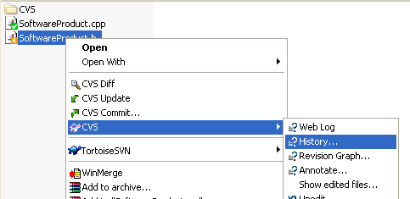

The software item revision from which the current modifications were performed will be selected. If the software product version to modify is no longer on that software item revision, it means that concurrent modifications occurred on the software item.

In the following screenshot, the software item revision from which the current modifications were performed is “1.1”. Since the software product version to modify, “SoftwareProduct-1-1”, is no longer on the software item revision “1.1”, it means that concurrent modifications occurred.

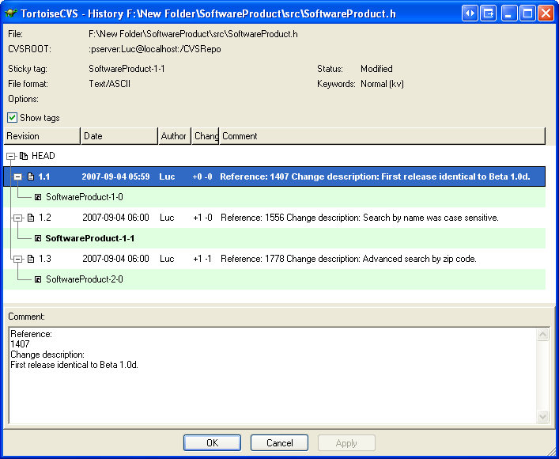

If concurrent modifications did not occur, skip this step. Right-click on the software product version to modify and select “Diff (working file)”.

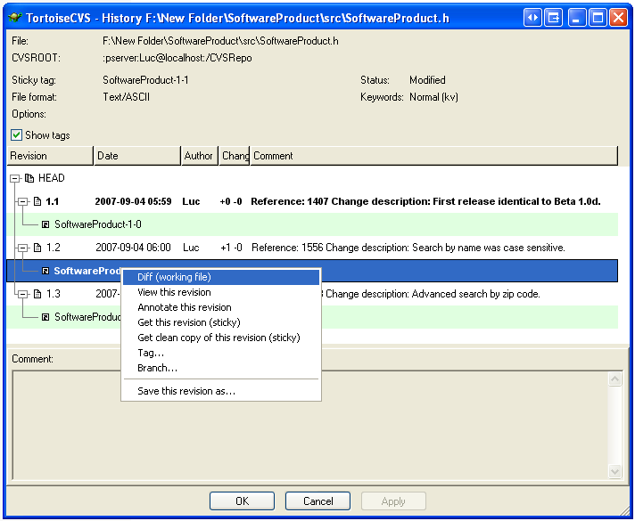

If concurrent modifications did not occur, skip this step. Use WinMerge to merge the concurrent modifications with the current modifications. Save the merged file.

Note that CVS has a built-in feature to merge automatically concurrent modifications by performing an update operation. This feature shall not be used since it can lead to unwanted bugs. Moreover, this feature will not behave correctly if branching is not used.

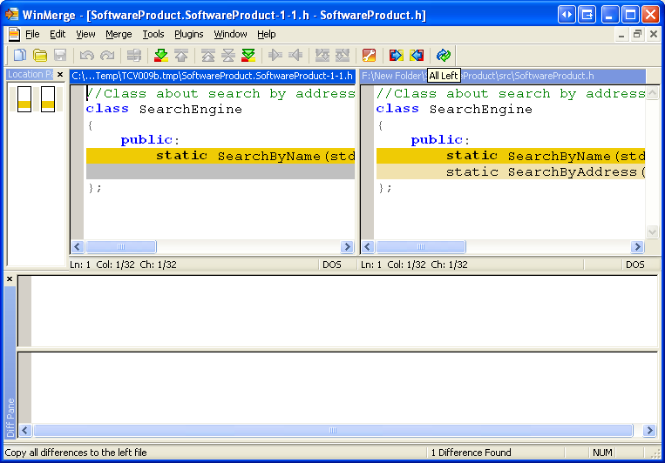

At this point, it is assumed that the concurrent modifications, if any, are merged with the current modifications on a local copy of the version.

Unfortunately, it is impossible to modify a software item on the CVS server using a copy of an existent version. First, it is necessary to download a copy of the “HEAD” version of all software items by performing task Download a copy of an existent software product version and selecting the “HEAD”. It is recommended to get a copy of the “HEAD” in a different directory.

Copy the modified software item under the “HEAD” directory. Right-click from inside the directory and select “CVS Commit…”.

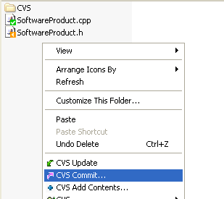

Write a comment that will enforce traceability with the version description. The reference and description of the change that requires the modification shall be recorded. More information may be recorded. Click the “OK” button.

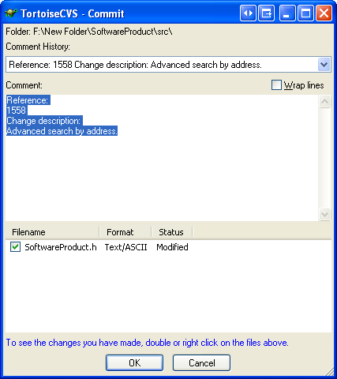

If successful, the following log will appear, listing the software item modified on the CVS server. Click the “OK” button.

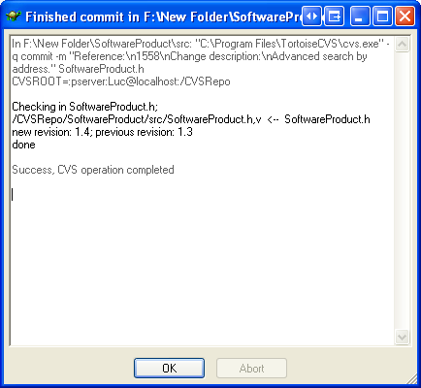

Right-click on the modified software item and select “CVS/History…”.

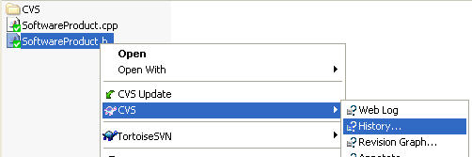

It is necessary to verify if multiple software product versions are overlapping. If the software product version to modify is not the latest on the software item, it means that multiple software product versions are overlapping.

In the following screenshot, the latest software product version on the software item is “SoftwareProduct-2-0”. Since the software product version to modify “SoftwareProduct-1-1” is not the latest on the software item, it means that software product versions are overlapping.

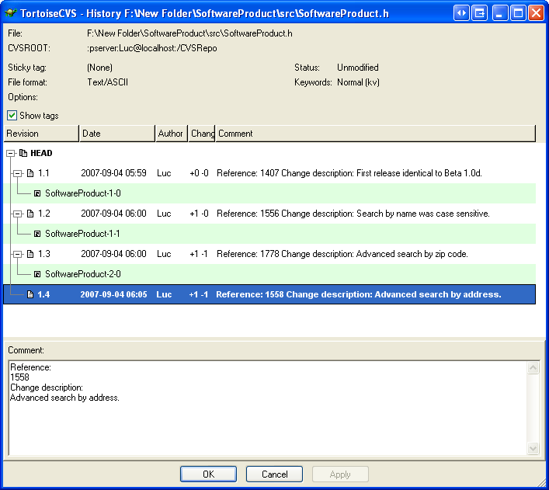

If software product versions are not overlapping, skip this step. Write additional comment that will enforce traceability. The software item revision from which the modifications were performed shall be recorded with “Modified from [revision number].”. Click the “Apply” button.

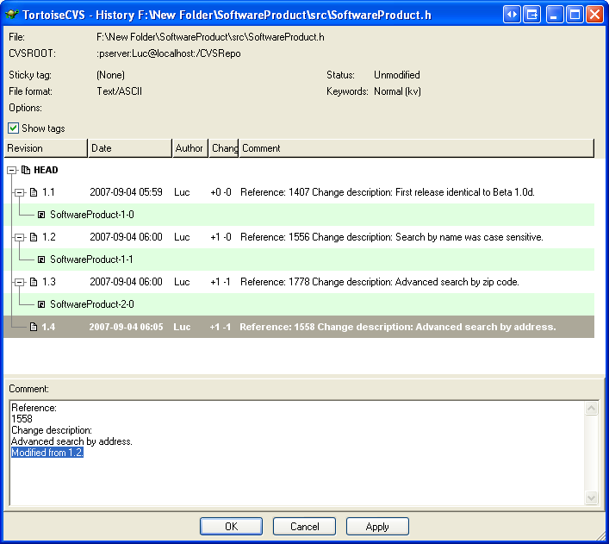

If successful, the following log will appear and disappear, listing the comment modified on the CVS server.

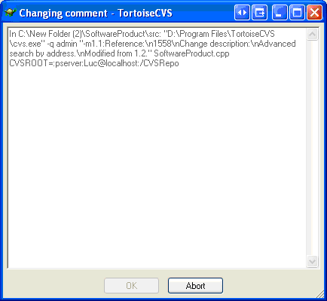

Right-click on the latest software item revision from the history and select “Tag…”.

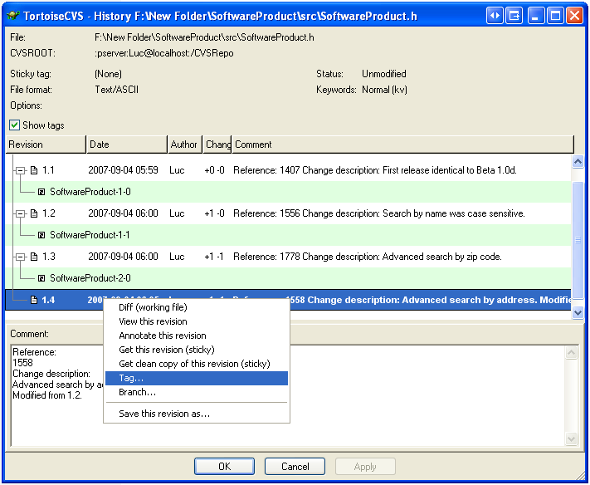

Select “Move existing tag” and enter the version in the combo box. Click the “OK” button.

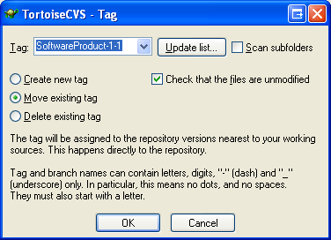

If successful, the following log will appear, listing the software item modified in the version. Click the “OK” button.

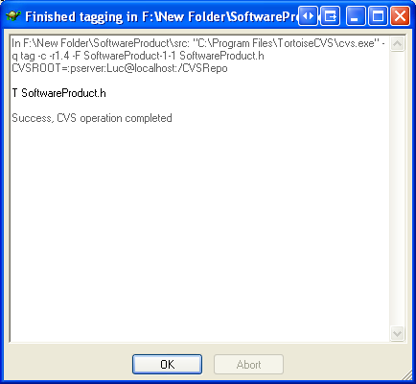

Verify that the software product version is linked to the correct software item revision and click “OK”.

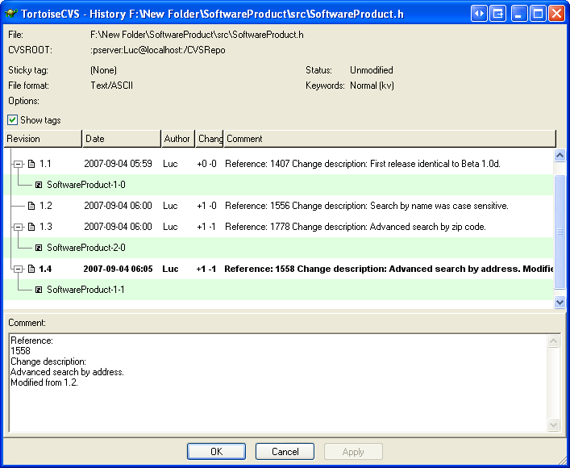

6. Reference to ISO and ISO/IEC Standards and Models

This appendix shows the traceability of this deployment package to ISO/IEC standards and to the Capability Maturity Model IntegrationSM version 1.2 (CMMI®).

Note: This appendix is provided for information purpose only.
Tables use the following convention:
- Full Coverage = F
- Partial Coverage = P
- No Coverage = N

Only tasks covered by this Deployment Package are listed in the matrices.

ISO/IEC29110 Part 5 (Basic Profile) Reference Matrix

Title of the Task and Step | Coverage  Full/Partial | Clause of ISO/IEC29110-5
3.1.1 Define the Delivery Instructions | Full | PM.1.2 Define with the Customer the Delivery Instructions of each one of the deliverables.
3.1.2 Document the Version Control Strategy | Full | PM.1.10 Document the Version Control Strategy in the Project Plan.
3.1.3 Establish the Project Repository | Full | PM.1.17 Establish or prepare the project repository using the Version Control Strategy.
3.1.4 Perform a Project Repository Backup | Full | PM.2.6 Perform backup according to the Version Control Strategy.
3.1.5 Perform a Project Repository Recovery | Full | PM.2.7 Perform Project Repository recovery using the Project Repository Backup, if necessary.
3.1.6 Incorporate Software Configuration Item | Full | SI.2.10 Incorporate the Requirements Specification, and Software User Documentation to the Software Configuration in the baseline.  SI.3.6 Incorporate the Software Design and Traceability Record in the Software Configuration as part of the baseline.  SI.4.8 Incorporate Components, Traceability Record and Test Cases and Test Procedures in the Software Configuration as part of the baseline.  SI.5.10 Incorporate the Software, Traceability Record, Defect Report, Product Operation Guide and Software User Documentation in the Software Configuration as part of the baseline.  SI.6.5 Incorporate the Maintenance Documentation as baseline for the Software Configuration.
3.1.7 Deliver a Software Configuration | Full | SI.6.6 Perform final delivery according to Delivery Instructions.

ISO/IEC 12207 Reference Matrix

Title of the Task and Step | Coverage  Full/Partial | Clause of ISO/IEC 12207
3.1.1 Define the Delivery Instructions | Full | 7.2.2.3.2 Configuration Identification  “A scheme shall be established for identification of software items and their versions to be controlled for the project.”
3.1.2 Document the Version Control Strategy | Partial | 7.2.2.3.1 Process implementation  “A software configuration management plan shall be developed.”
3.1.3 Establish the Project Repository | Partial | 7.2.2.3.1 Process implementation  “The plan shall be […] implemented.”
3.1.4 Perform a Project Repository Backup | Partial | 6.3.5.3.1 Configuration management planning  “Defining the locations and conditions of storage […], storage media, in accordance with designated levels of integrity, security and safety.”  7.2.2.3.1 Process implementation  “The plan shall be […] implemented.”
3.1.5 Perform a Project Repository Recovery | Partial | 6.3.5.3.1 Configuration management planning  “Defining the locations and conditions of storage […], storage media, in accordance with designated levels of integrity, security and safety.”  7.2.2.3.1 Process implementation  “The plan shall be […] implemented.”
3.1.6 Incorporate Software Configuration Item | Partial | 7.2.2.3.3 Configuration Control  “The following shall be performed:[…] implementation and release of the modified software item.”
3.1.7 Deliver a Software Configuration | Full | 7.2.2.3.6 Release management and delivery  “The release and delivery of software products […] shall be formally controlled.”

CMMI Reference Matrix

Title of the Task and Step | Coverage  Full/Partial | Goal/Practice of CMMI V1.2
3.1.1 Define the Delivery Instructions | Full | Configuration Management  SP 1.1 Identify Configuration Items  “Identify the configuration items, components, and related work products that will be placed under configuration management.”
3.1.2 Document the Version Control Strategy | Partial | Configuration Management  GP 2.2 Plan the Process  “Establish and maintain the plan for performing the configuration management process.”
3.1.3 Establish the Project Repository | Partial | Configuration Management  SP 1.2 Establish a Configuration Management System  “Establish and maintain a configuration management […] system for controlling work products.”
3.1.4 Perform a Project Repository Backup | Partial | Configuration Management  SP 1.2 Establish a Configuration Management System  “Preserve the contents of the configuration management system. […] Examples of preservation functions […] include […] backups of configuration management files.”
3.1.5 Perform a Project Repository Recovery | Partial | Configuration Management  SP 1.2 Establish a Configuration Management System  “Preserve the contents of the configuration management system. […] Examples of preservation functions […] include […] restoration of configuration management files.”
3.1.6 Incorporate Software Configuration Item | Partial | Configuration Management  SP 1.2 Establish a Configuration Management System  “Store and retrieve configuration items in a configuration management system.”
3.1.7 Deliver a Software Configuration | Full | Configuration Management  SP 1.3 Create or Release Baselines  “Create or release baselines for internal use and for delivery to the customer.”

7. References

Key | Reference
[ISO/IEC 24765] | ISO/IEC 24765, Systems and Software Engineering Vocabulary.
[ISO/IEC29110-5-1] | ISO/IEC ISP 29110-5-1, Software Engineering—Lifecycle Profiles for Very Small Entities (VSEs) – Part 5-1: Management and Engineering Guide – Basic Profile
[ISO/IEC12207] | ISO/IEC 12207:2008 Systems and software engineering - Software life cycle processes.
[CMU/SEI-90-TR-11] | CMU/SEI-90-TR-11 Spectrum of Functionality in Configuration Management Systems.  http://www.sei.cmu.edu/legacy/scm/tech_rep/TR11_90/TOC_TR11_90.html
[CMU/SEI-2006-TR-008] | CMU/SEI-2006-TR-008 CMMI® for Development, Version 1.2.

8. Evaluation Form

Deployment Package- Version Control with CVS– Version 0.2
Your feedback will allow us to improve this package, your comments and suggestions are welcomed
1. How satisfied are you with the CONTENT of this deployment package?

❑ Very Satisfied  Satisfied  Neither Satisfied nor Dissatisfied  Dissatisfied  Very Dissatisfied
2. The sequence in which the topics are discussed, are logical and easy to follow?

❑ Very Satisfied  Satisfied  Neither Satisfied nor Dissatisfied  Dissatisfied  Very Dissatisfied

3. How satisfied were you with the APPEARANCE/FORMAT of this deployment package?
❑ Very Satisfied  Satisfied  Neither Satisfied nor Dissatisfied  Dissatisfied  Very Dissatisfied
4. Have any unnecessary topics been included? (please describe)

5. What missing topic would you like to see in this package? (please describe)
- Proposed topic:
- Rationale for new topic
- Any error in this deployment package?
  - Please indicate:
      - Description of error :
      - Location of error (section #, figure #, table #) :
7. Other feedback or comments
8. Would you recommend this Deployment package to a colleague from another VSE?

❑ Definitely  Probably  Not Sure  Probably Not  Definitely Not
Optional
- Name:
- e-mail address : __________________________________

Email this form to : claude.y.laporte@etsmtl.ca or Avumex2003@yahoo.com.mx

Roles are defined in a next section. Roles are also defined in ISO/IEC 29110 Part 5-1
SM CMM Integration is a service mark of Carnegie Mellon University. ® Capability Maturity Model, CMMI are registered in the U.S. Patent and Trademark Office by Carnegie Mellon University.

